SQL CLASS - 1

TOPICS - Introduction

What is Database?

A storage area where groups of tables that contain data about entities are stored.
An entity is anything, a person, a place, an event etc. that has information.

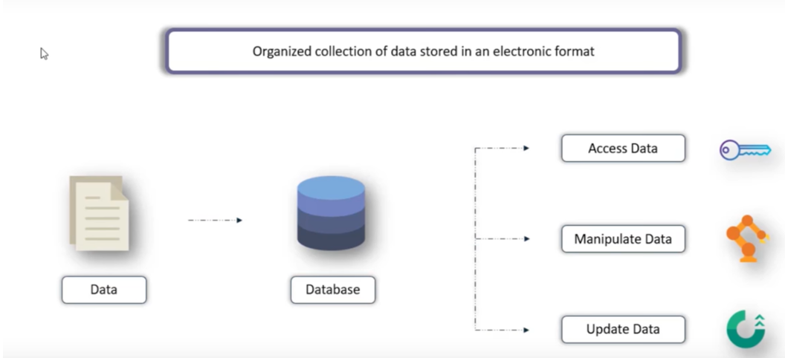

Database Management System (DBMS)
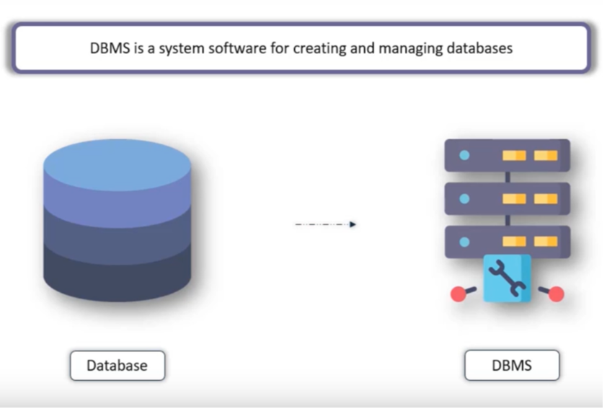
- Database management system is a software that is used to create, maintain and provide controlled access to user databases while considering appropriate security measures.
- The DBMS accepts the request for data from an application and instructs the operating system to provide the specific data.
- DBMS allows users to create their own databases as per their requirement.
- Database management systems should provide systematic method of
- Creating the Database.
- Updating the Database.
- Dropping the Database
- Retrieving of data from Database
- Should provide facility for….
- Controlling data access.
- Enforce data integrity.
- Manage concurrency control.
- Restoring the data in system failures.

Different database Models and their Timelines
- Flat file DBMS (1960)
- Hierarchical DBMS (1970)
- Network DBMS (1980)
- Relational DBMS (1990)
- Object-Relational DBMS (2000)

What is Data?
Data is a raw and unorganized. Data is a collection of values. Those values can be characters, numbers, or any other data type. If those values are not processed, they have little meaning to a human.
What is Information?
Information is data that was processed so a human can read, understand, and use it.
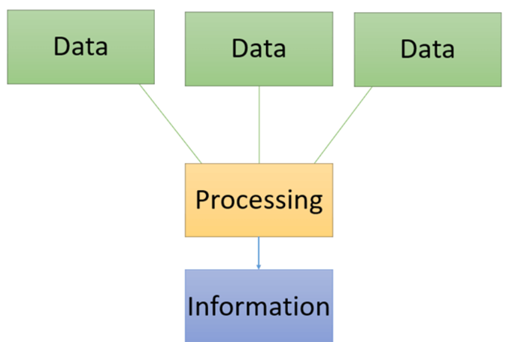

Examples of Data and Information
The following is an example of raw data, and how that data can be processed into information.
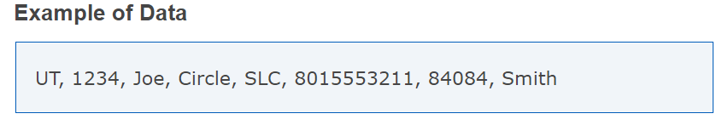
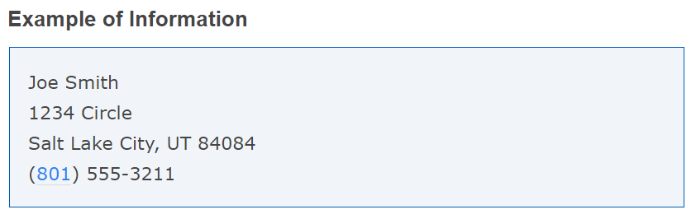

What is Structured Query language (SQL)?

It is used to communicate with the database.

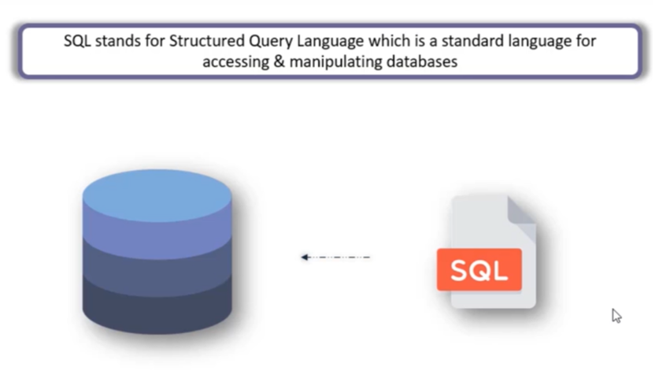

- Structure query language is commonly pronounced as SEQUEL.
- SEQUEL later becomes SQL.
- Dr E.F Codd published the paper on relational database models in June 1970 at IBM Corporation, Inc.
- It allows the user to communicate as the server.
- It is easy to learn and use.
- It is functionally complete, by allowing the user to define, retrieve and manipulate the data.

How Data is Stored in the Database?

Data stored in the database in table format.

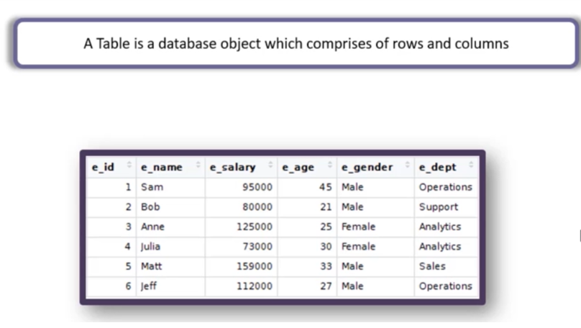

Rows/ Tuple are known as records and Columns/ Attribute are known as Fields

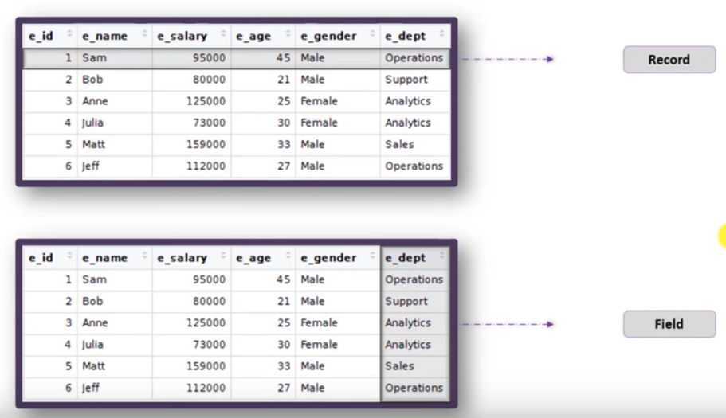

- A Field provides specific information about data in the table like salary column provides salary of different employees similarly the age column provides age of different employees.
- A field can have only one value, or may not have a value at all, the absence of value in Oracle is represented as NULL.

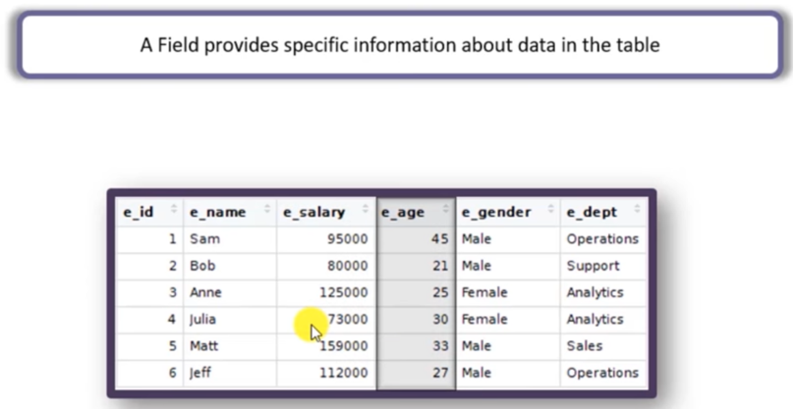

Records provide complete information of a particular employee.

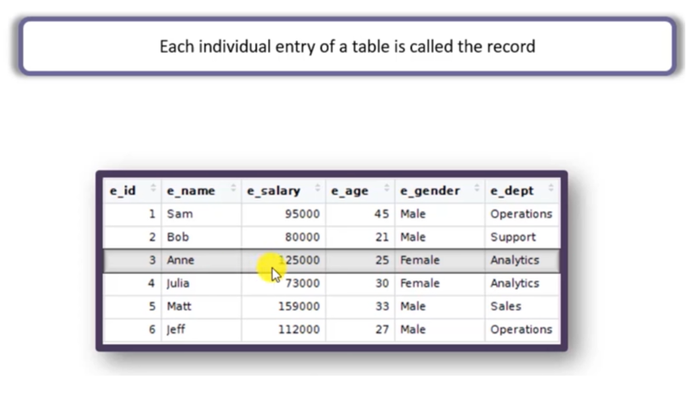

What is Metadata?
Metadata is the data which describes the properties or characteristics of end user’s data and the context of the data.
It include information such as:
Data Name - It is a user created objects name (Like name of a Table)
Definitions - It contains Attributes (Column Names) and its Data types.
Size of Data - Size of the data. (Column Size)
Values Allowed - It is used to accept a type of data into an attribute.
Metadata and data are always separate.
Metadata enables the database designers and programmers to understand exactly in which form the data should exist within the system.

__________________________THANK YOU____________________________

